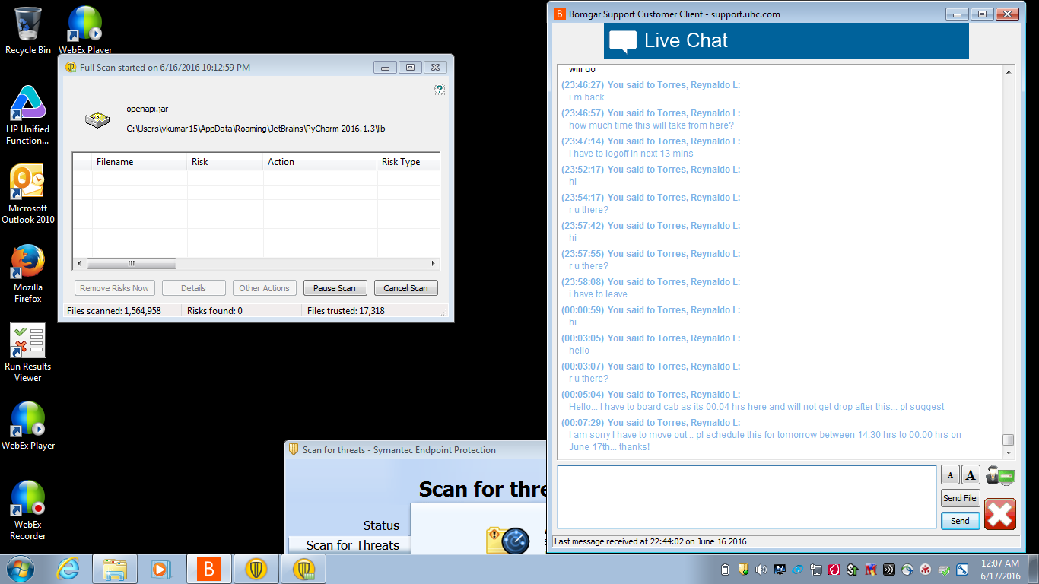

**Important Reports in SAP FI**

**Details**

Last Updated: Tuesday, 29 March 2016 12:09

This tutorial will give you an overview of important reports which are used frequently in SAP FI. Following is list of important reports

1. GL Chart Of Accounts List
2. GL Account List
3. GL Account Balances
4. GL Account Totals And Balances
5. AR Customer Master Data List
6. AR Customer Balances
7. AR Customer Line Items
8. AR Customer Open Item Analysis Drilldown Report
9. AR Customer Payment History
10. AP Vendor Master Data List
11. AP Vendor Balances
12. AP Vendor Line Items
13. AP Vendor Open Item Analysis

We will now discuss them one by one.

**GL Chart Of Accounts List**

Enter Transaction Code S_ALR_87012326 in the SAP Command Field

[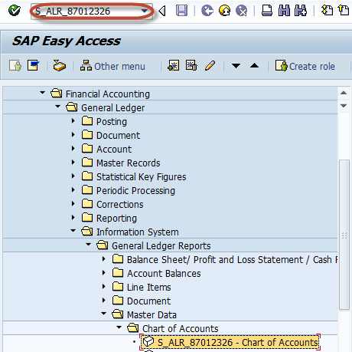](http://cdn.guru99.com/images/sap/2012/05/CoaBal011.png)

In the next screen , Enter Chart of Account Key

[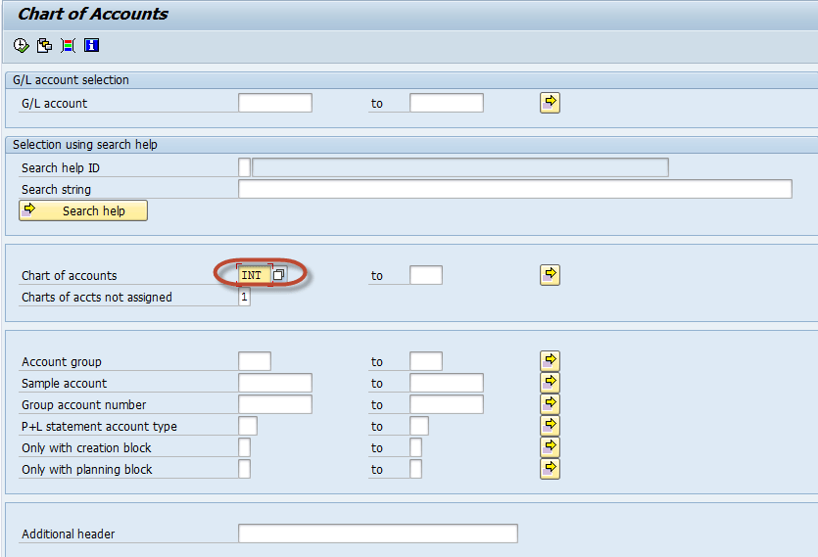](http://cdn.guru99.com/images/sap/2012/05/CoaBal021.png)

Press F8 (Execute) The GL Chart of Accounts List is Generated for COA key mentioned in the last screen

[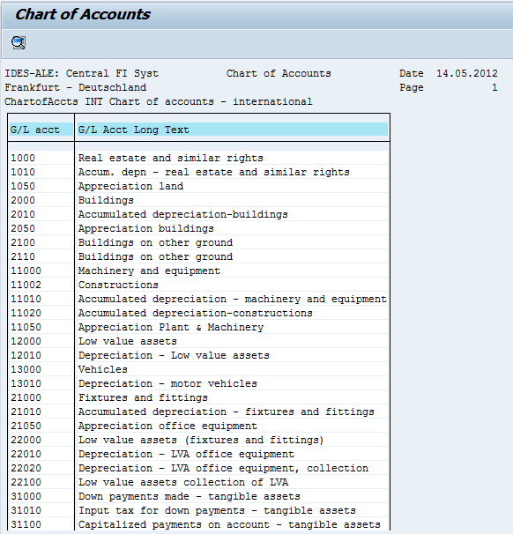](http://cdn.guru99.com/images/sap/2012/05/CoaBal032.png)

**GL Account List**

Enter Transaction Code S_ALR_87012328  in SAP Command Field

[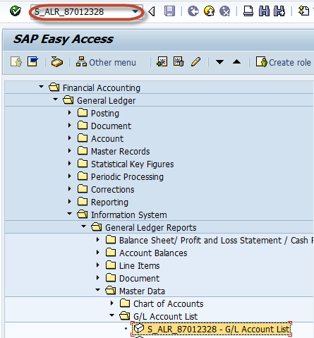](http://cdn.guru99.com/images/sap/2012/05/AccLst011.png)

  In the next screen, Enter Selection Parameters like Company Code / Chart of Accounts / GL Account for Filtering. Entering these parameters is optional

[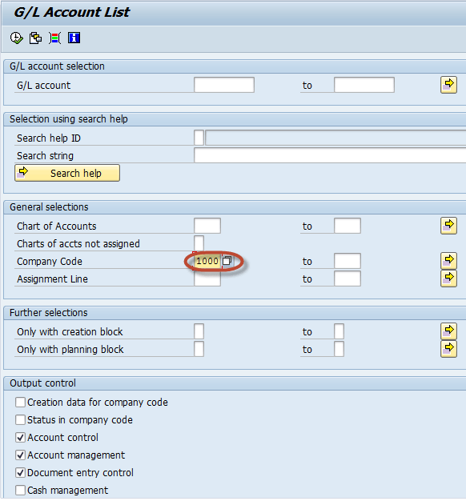](http://cdn.guru99.com/images/sap/2012/05/AccLst021.png)

  Press F8 (Execute) The GL Account List is generated as per the filtering selections from the previous screen . Otherwise complete list is generated for all company code and chart of accounts

[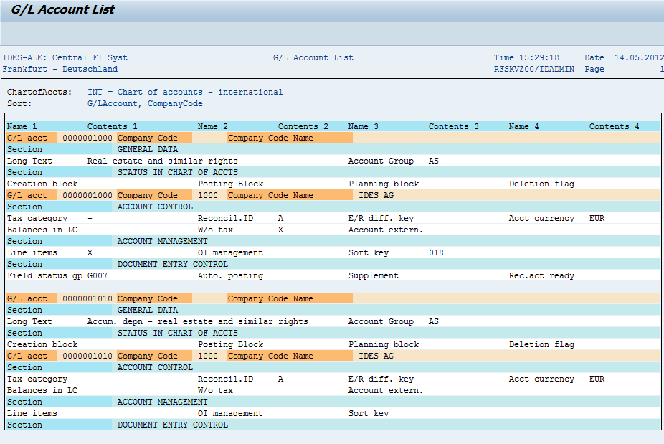](http://cdn.guru99.com/images/sap/2012/05/AccLst031.png)

**GL Account Balances**

Enter Transaction Code S_ALR _87012277  in the SAP Command Field

[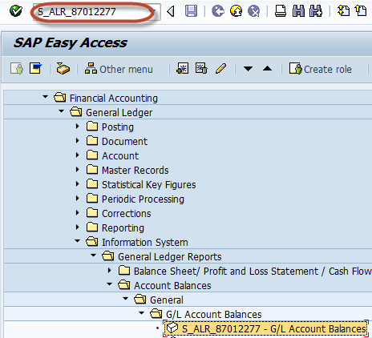](http://cdn.guru99.com/images/sap/2012/05/AccBal011.png)

In the next screen, Enter Selection Parameters for Filtering the Report such as Company code / GL Account

[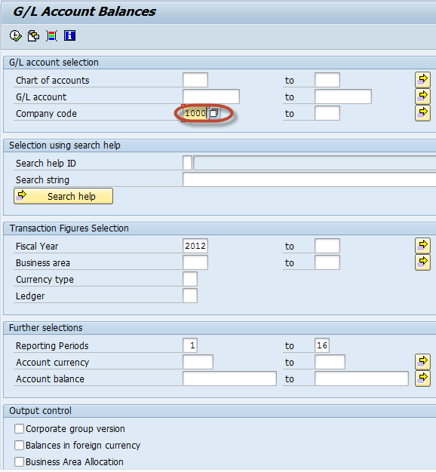](http://cdn.guru99.com/images/sap/2012/05/AccBal021.png)

  Press F8 (Execute) In the next screen, GL Account Balance List is generated as per the parameters entered in the previous screen

[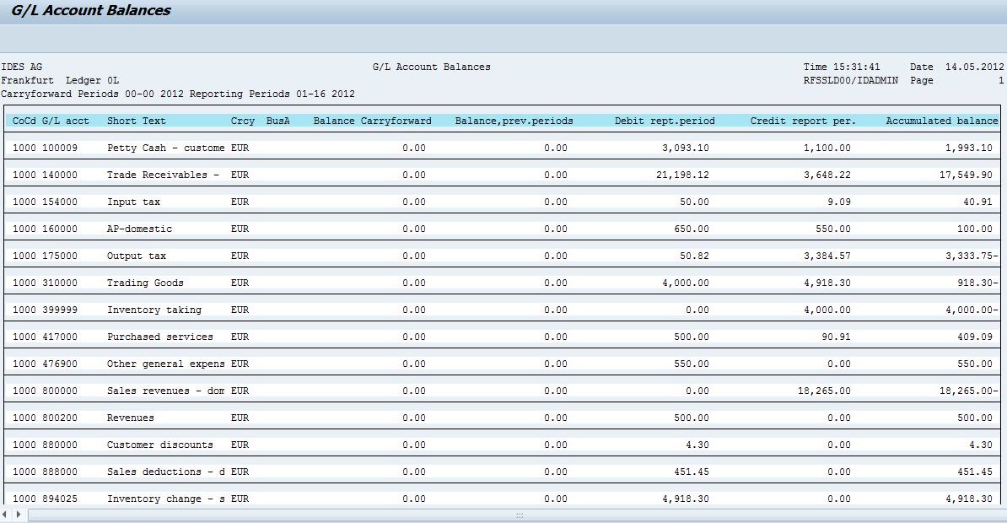](http://cdn.guru99.com/images/sap/2012/05/AccBal032.png)

**GL Account  Totals and Balances**

Enter Transaction code S_ALR_ 87012301 in the Sap Command Field

[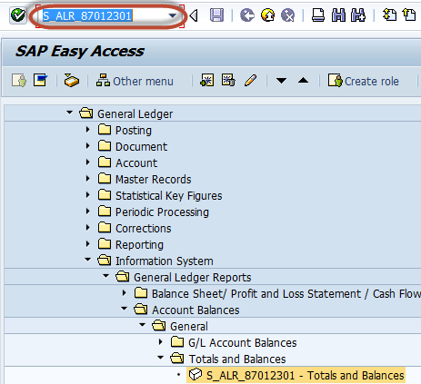](http://cdn.guru99.com/images/sap/2012/05/GLtotnBal01.png)

In the next screen , Enter Selection Criteria like Company Code/ COA / Gl Accounts for the filtering the Report

[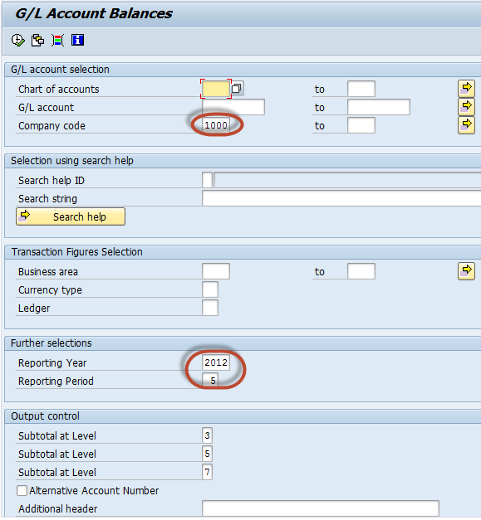](http://cdn.guru99.com/images/sap/2012/05/GLtotnBal02.png)

  In the next screen , GL Account Total and Balance report is generated as per the parameters selected in the previous screen

[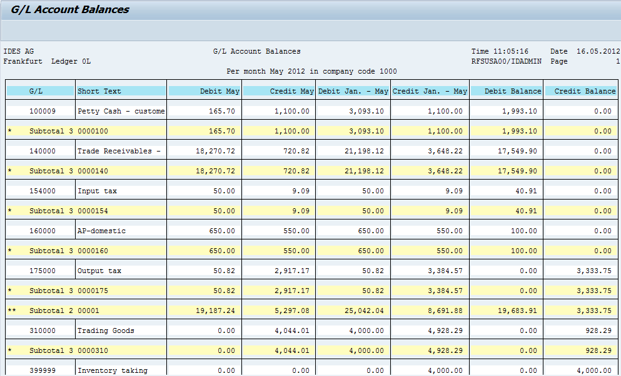](http://cdn.guru99.com/images/sap/2012/05/GLtotnBal03.png)

**AR Customer Master Data List**

  Enter Transaction S_ALR_87012179  in SAP Command Field

[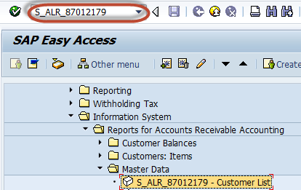](http://cdn.guru99.com/images/sap/2012/05/Cuslist01.png)

  In the next screen , Enter Selection Criteria for the filtering the Report

[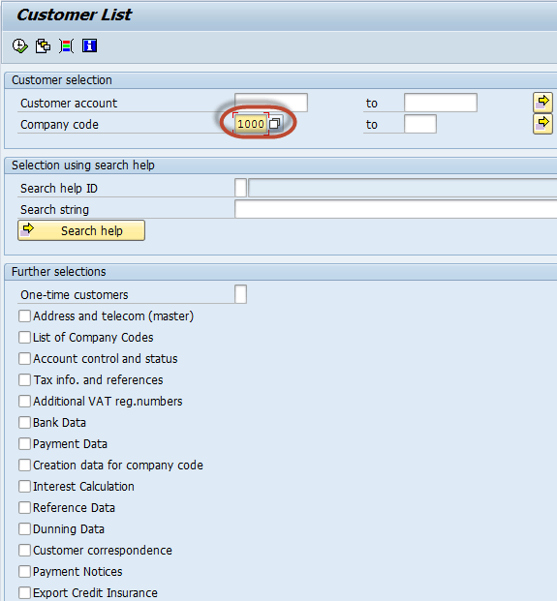](http://cdn.guru99.com/images/sap/2012/05/Cuslist02.png)

  In the next screen , AR Customer Master Data List is  generated as per the parameters selected in the previous screen

[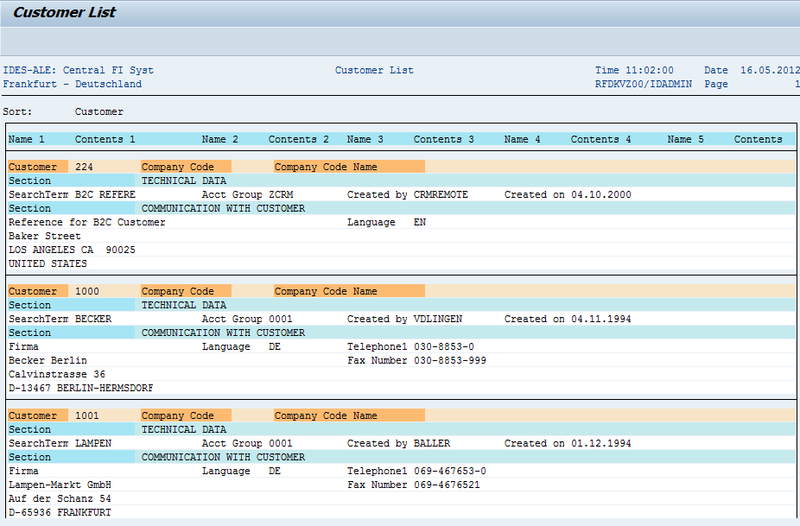](http://cdn.guru99.com/images/sap/2012/05/Cuslist03.png)

**AR Customer Balances**

Enter Transaction Code S_ALR_87012172 in the SAP Command Field

[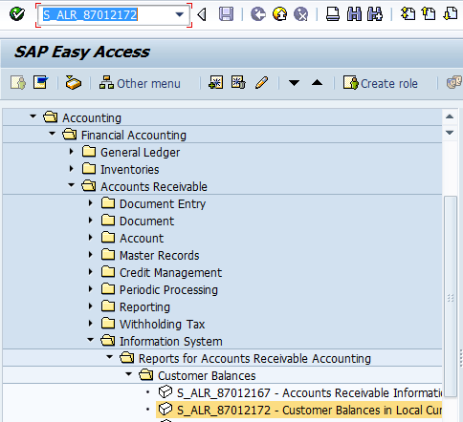](http://cdn.guru99.com/images/sap/2012/05/CusBal01.png)

In the next screen , Enter Selection Criteria for the filtering the Report

[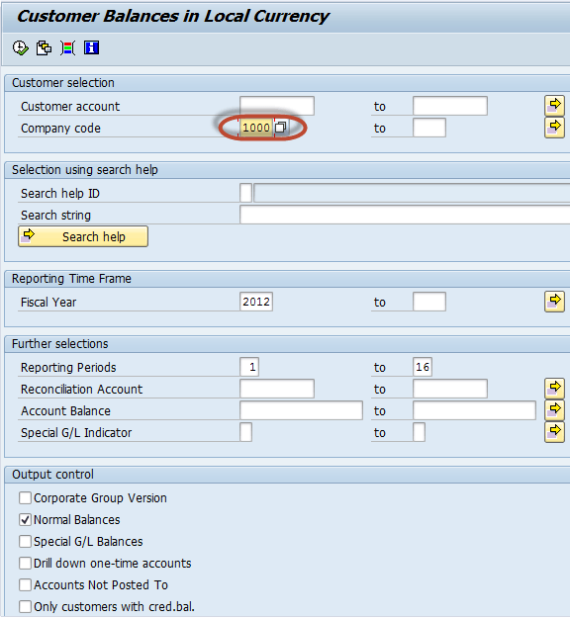](http://cdn.guru99.com/images/sap/2012/05/CusBal021.png)

  In the next screen , AR Customer Balance Report  is  generated as per the parameters selected in the previous screen

[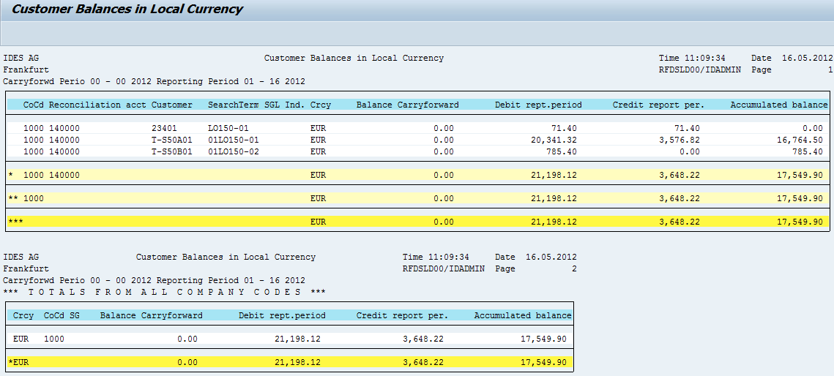](http://cdn.guru99.com/images/sap/2012/05/CusBal03.png)

**AR Customer Line Items**

  Enter Transaction Code S_ALR_87012197 in the SAP Command Field

[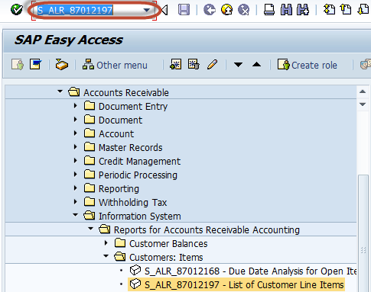](http://cdn.guru99.com/images/sap/2012/05/CusLinItem01.png)

In the next screen , Enter Selection Criteria for the filtering the Report

[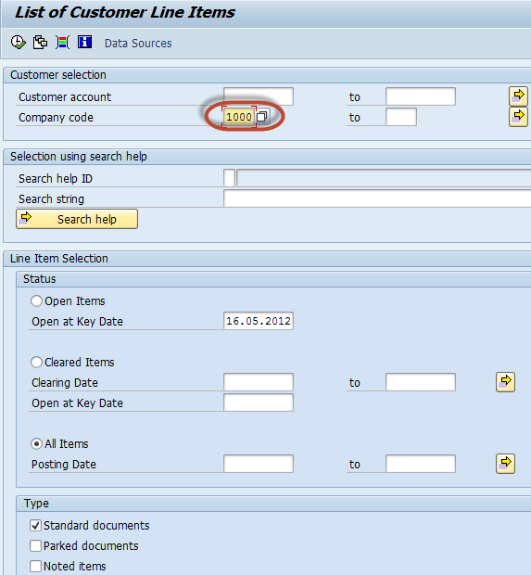](http://cdn.guru99.com/images/sap/2012/05/CusLinItem02.png)

In the next screen , AR Customer Line Item Report  is  generated as per the parameters selected in the previous screen

[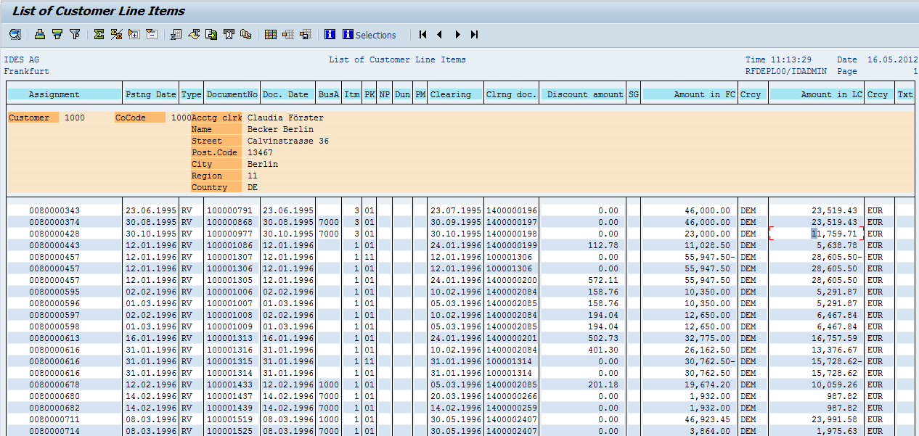](http://cdn.guru99.com/images/sap/2012/05/CusLinItem03.png)

**AR Customer Open Items**

  Enter Transaction Code S_ALR_87012174  in the SAP Command Field

[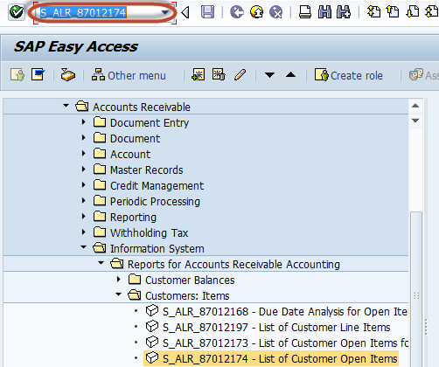](http://cdn.guru99.com/images/sap/2012/05/CustOpen011.png)

In the next screen , Enter Selection Criteria for the filtering the Report

[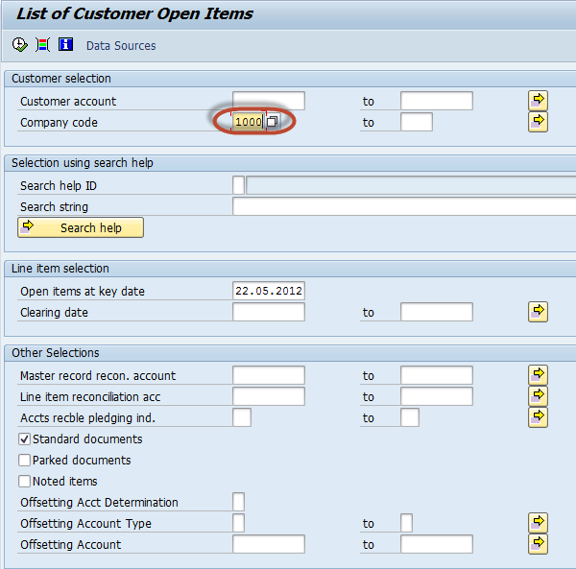](http://cdn.guru99.com/images/sap/2012/05/CustOpen021.png)

  In the next screen , AR Customer Open Item Report  is  generated as per the parameters selected in the previous screen

[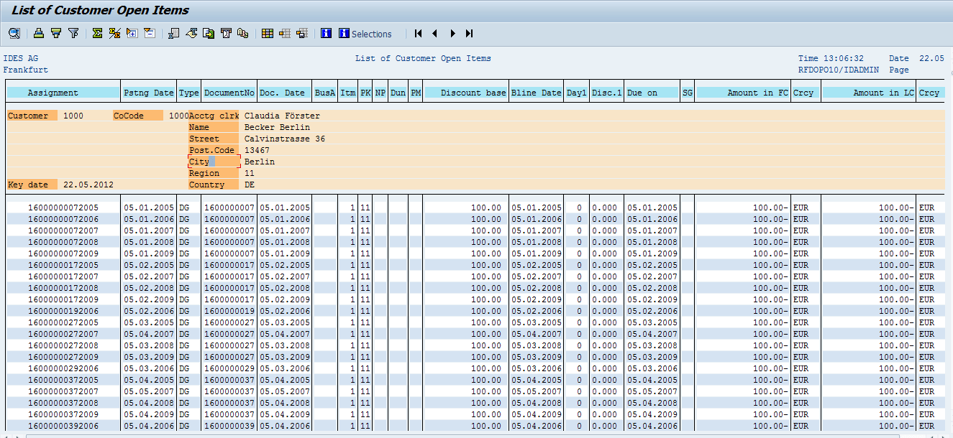](http://cdn.guru99.com/images/sap/2012/05/CustOpen03.png)

**AR Customer Payment History**

Enter Transaction Code S_ALR_87012177 in SAP Command Field

[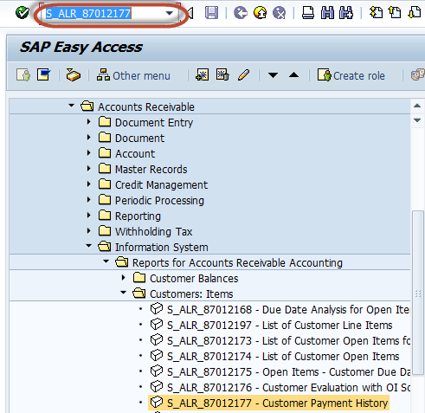](http://cdn.guru99.com/images/sap/2012/05/CustPayH01.png)

In the next screen , Enter Selection Criteria for the filtering the Report

[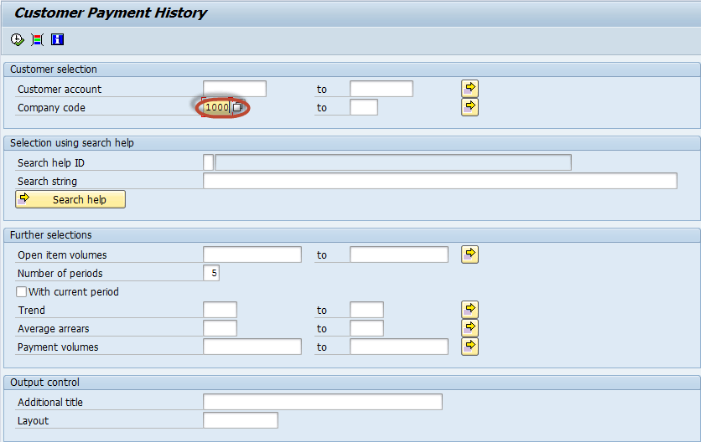](http://cdn.guru99.com/images/sap/2012/05/CustPayH02.png)

In the next screen , AR Customer Payment History Report  is  generated as per the parameters selected in the previous screen

[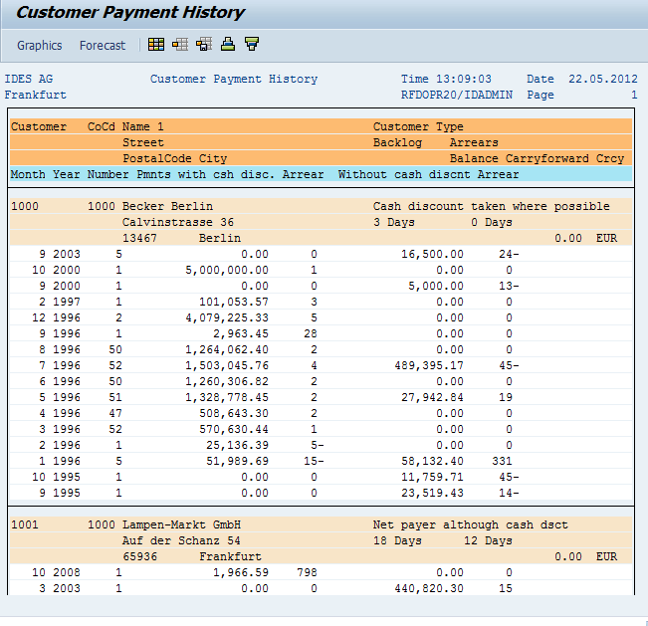](http://cdn.guru99.com/images/sap/2012/05/CustPayH03.png)

**AP Vendor Master Data List**

Enter Transaction Code S_ALR_87012086  in SAP Command Field

[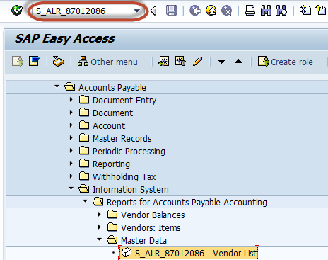](http://cdn.guru99.com/images/sap/2012/05/VendList01.png)

In the next screen , Enter Selection Criteria for the filtering the Report

[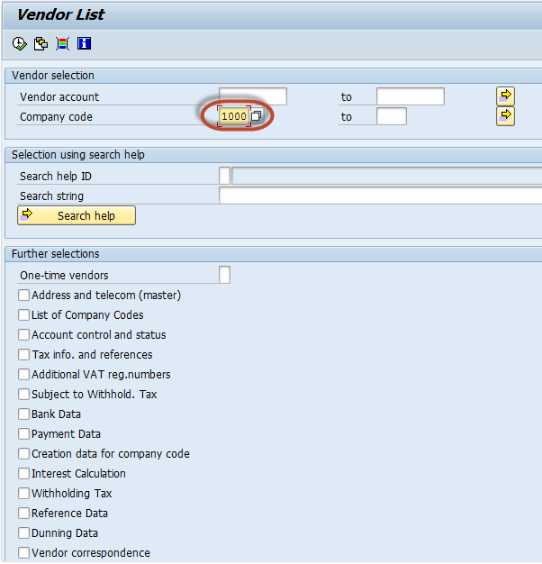](http://cdn.guru99.com/images/sap/2012/05/VendList02.png)

In the next screen , AP Vendor Master Data List Report  is  generated as per the parameters selected in the previous screen

[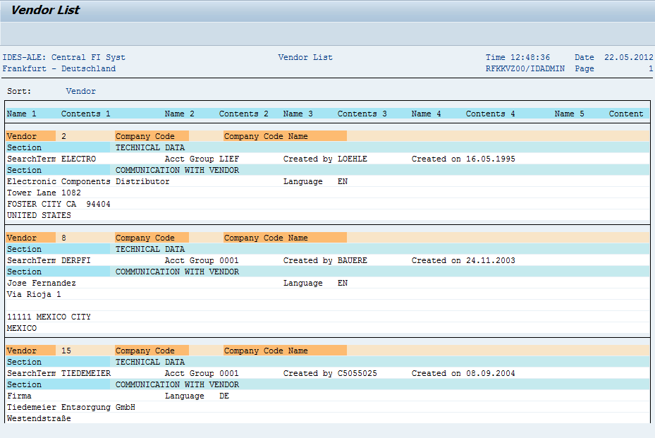](http://cdn.guru99.com/images/sap/2012/05/VendList03.png)

**AP Vendor Balances**

Enter Transaction Code S_ALR_87012082 in SAP Command Field

[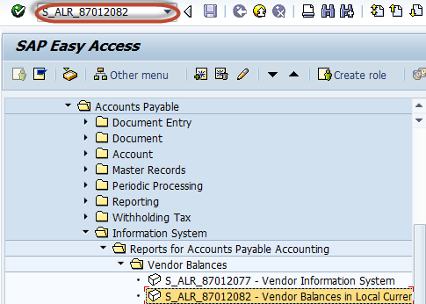](http://cdn.guru99.com/images/sap/2012/05/VendBal01.png)

In the next screen , Enter Selection Criteria for the filtering the Report

[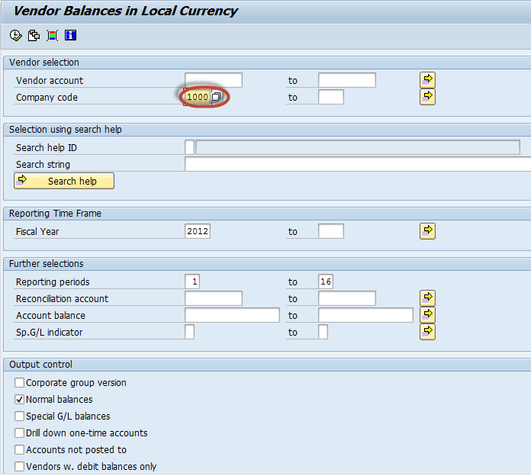](http://cdn.guru99.com/images/sap/2012/05/VendBal02.png)

In the next screen , AP Vendor Balances Report  is  generated as per the parameters selected in the previous screen

**[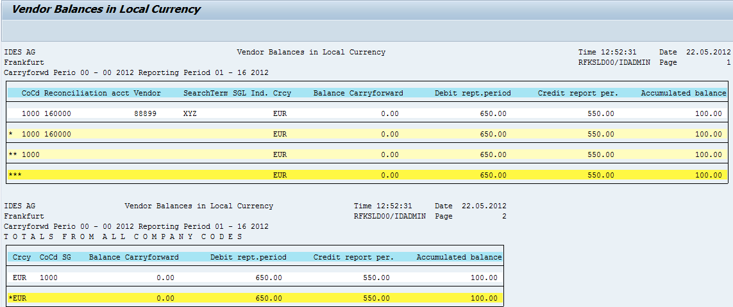](http://cdn.guru99.com/images/sap/2012/05/VendBal03.png)**

**AP Vendor Line Items**

Enter Transaction Code S_ALR_87012103 in SAP Command Field

[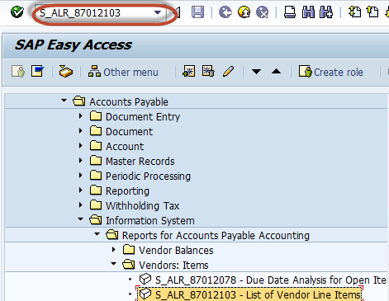](http://cdn.guru99.com/images/sap/2012/05/VendLine01.png)

In the next screen , Enter Selection Criteria like Company code / Vendor Accounts for the filtering the Report

[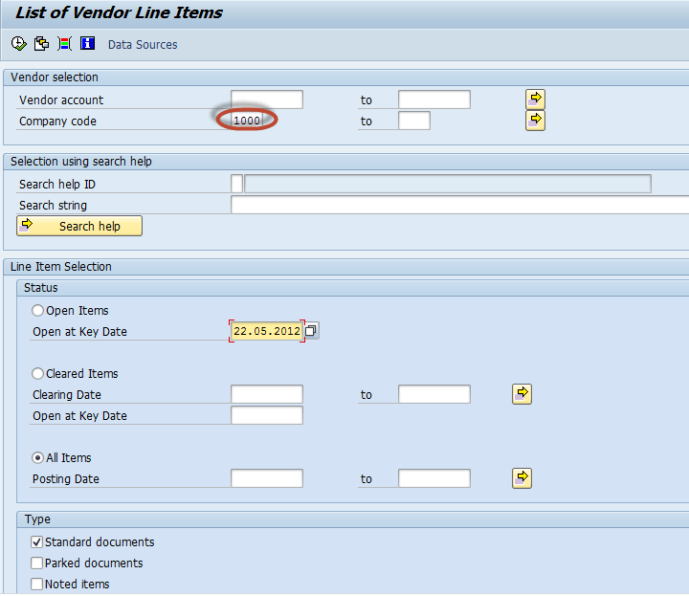](http://cdn.guru99.com/images/sap/2012/05/VendLine02.png)

In the next screen , AP Vendor Line Items  List Report  is  generated as per the parameters selected in the previous screen

**[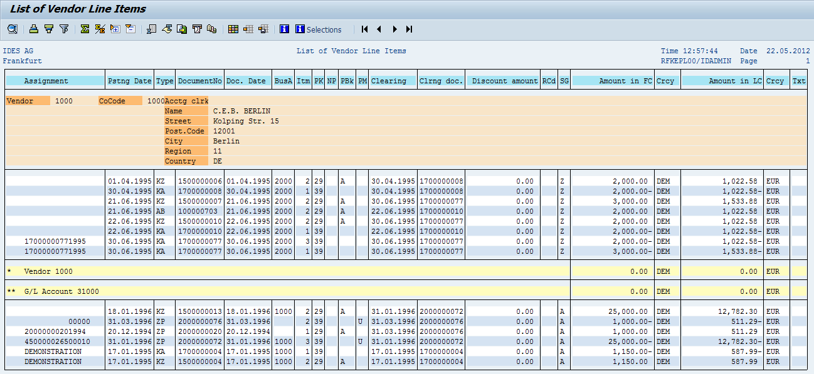](http://cdn.guru99.com/images/sap/2012/05/VendLine03.png)**

**AP Vendor Open Item Analysis**

Enter Transaction Code S_ALR_87012083  in SAP Command Field

[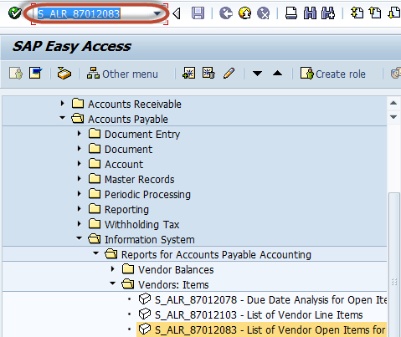](http://cdn.guru99.com/images/sap/2012/05/VendPay012.png)

In the next screen , Enter Selection Criteria for the filtering the Report

[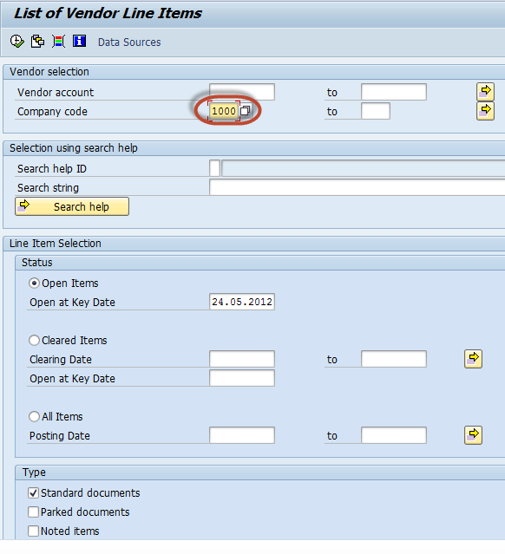](http://cdn.guru99.com/images/sap/2012/05/VendPay021.png)

In the next screen , AP Vendor Open Item Analysis Report  is  generated as per the parameters selected in the previous screen

[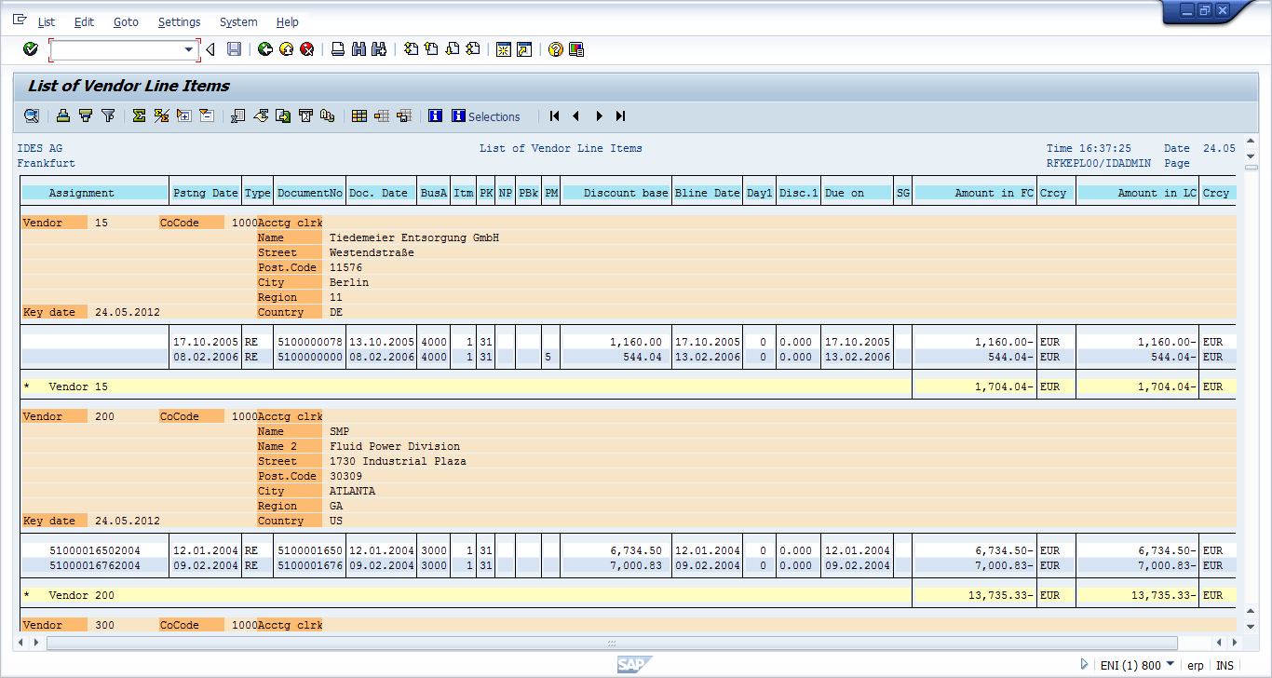](http://cdn.guru99.com/images/sap/2012/05/VendPay031.png)